# Lab: Password Cracking

## NISGTC Security + Lab Series

## Lab 8: Mitigation and Deterrent Techniques – Password Cracking

Complete the attached lab in Netlab+.

To log in to Netlab+ go to <http://netlab.columbusstate.edu>.

Reserve a pod for individual use.

**Note:** Step 7 in Section 2 (Cracking Windows Passwords) does not work because hashcat is not installed in the system. Because the system is not connected to the Internet we cannot install it. Therefore, Step 7 will not work for you but if it had worked, you’d get the output you see in the file.

Take screenshots of your work at these steps and **copy them in this document:**

Step 16 of 1.1 on page 10

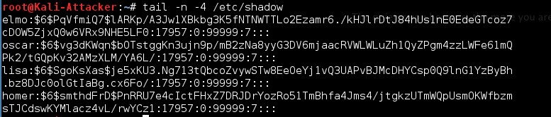

Step 2 of 1.2 on page 10

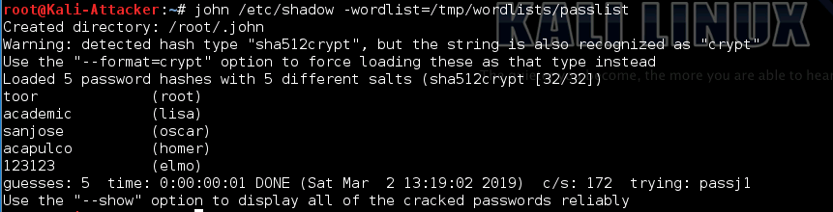

Step 6 of 2.1 on page 12

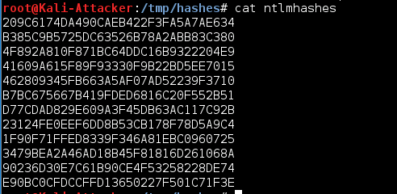

Step 12 of 3.1 on page 15

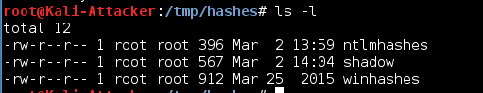

Step 13 of 3.2 on page 19

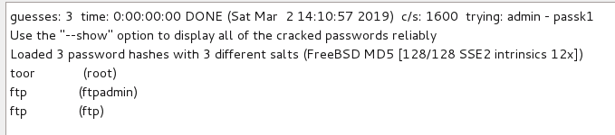

Note: You can use the Snipping Tool to take the screenshots on a Windows machine

**Provide answers to these questions (in this document. Please use a different color for your responses)**

1. **In the lab, where and how was John the Ripper used? Describe briefly how it works.**

Solution: John the Ripper is a widely known open source password-cracking tool. It is primarily used for cracking Unix passwords. In this lab, John the Ripper is run against the shadow file under /etc directory, by the support of Wordlist mode. This mode requires a wordlist to be supplied when John the Ripper is run and generates hashes for each of the strings in the wordlist before comparing those hashes to the hashes of the passwords to be cracked.

1. **What is the name of the tool used to crack the ntlm hashes?**

Solution: Hashcat

1. **How did you get the shadow file from the DVL in the lab?**

Solution: Firstly, access the DVL Server to initialize the FTP service. Secondly in Kali system, remotely FTP into the DVL Server and get the shadow file under /etc directory which is under /root directory, then close the FTP session after downloading shadow file into the target directory that is in Kali system.

**Submit your assignment in the Dropbox in CougarView.**

**Grading Rubric:**

|  |  |
| --- | --- |
|  | MaxPoints |
| Screenshots from Lab | 5 |
| Answers to questions | 4 |
| Style | 1 |
| Total | 10 |